Adhesive bond strength test rig

This test rig was designed to fit in the in house 12 ton hydraulic shop press and measure the breaking strength of different adhesive joint designs. I ran FEA simulations and itterated the design to support 500 lbs with a yielding factor of safety of over 3. A strain guage load cell was used selected to measure force the adhesive breaking force. In addition to the mechaical design and wiring, I wrote the test plan and programed the arduino.

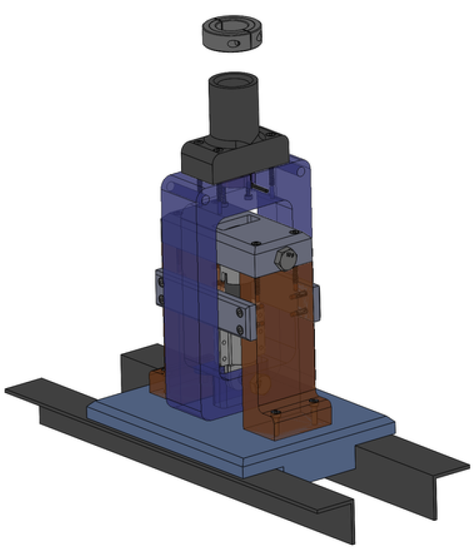 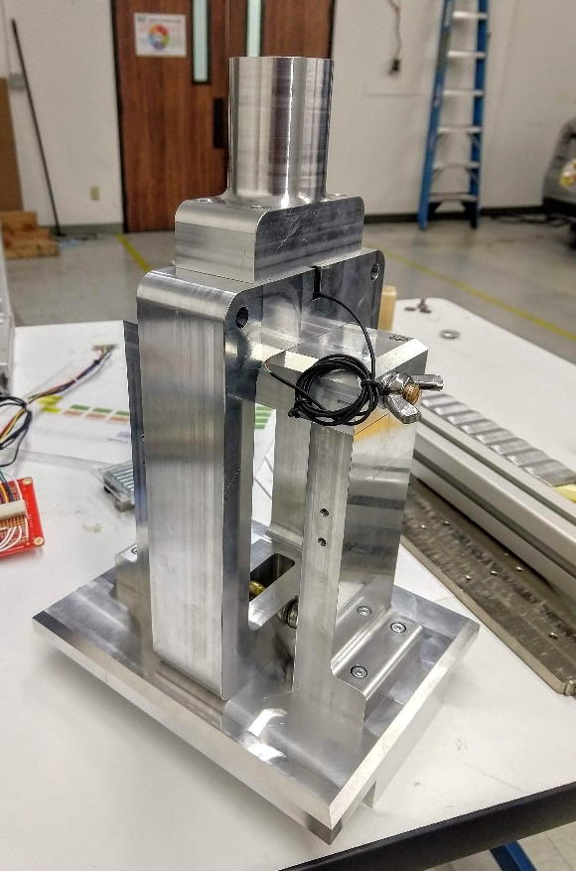

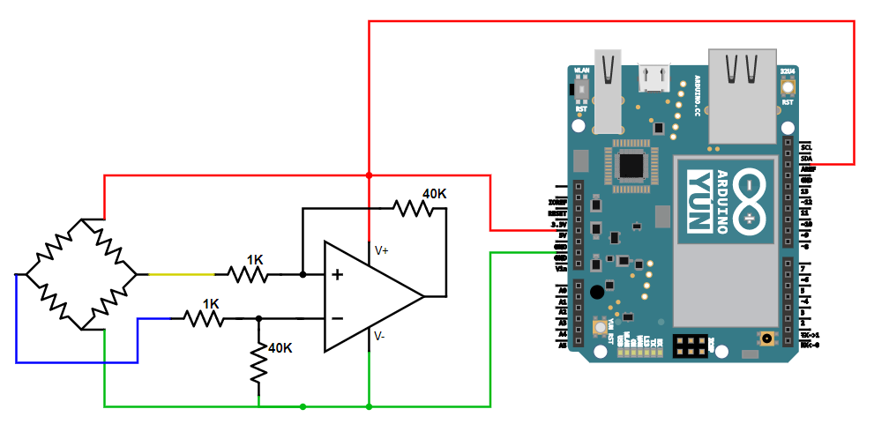

Circuit diagram: The differential amplifier was needed to amplify the bridge voltage to a level readable by the Arduino. The Arduino was used to log data and save the breaking force.